Kerimkulova Adiya 9 E

Nis PhM Taraz

**Problem.**

Leaders and scientists of many nations are currently trying to find a solution to the major issue of increasing CO2 emissions as reported by many NEWS organizations around the world. which prompted me to create an automated installation that can effectively absorb carbon dioxide. Many existing designs were investigated and found that most of them are not automated, and also use filters that are dangerous to humans.

**Absorber.**

Possible absorbers of CO2 was investigated, it turned out that the properties of NaOH are ideal for it, and filters impregnated with it can be worked out as fillers for doorways for its sound and noise insulating properties.

**Creation of an automated carbon dioxide absorber from gaseous industrial waste.**

In designing the layout of the automated absorber plans of its operation along with 3D models were created in bear ghost 5 3D printer

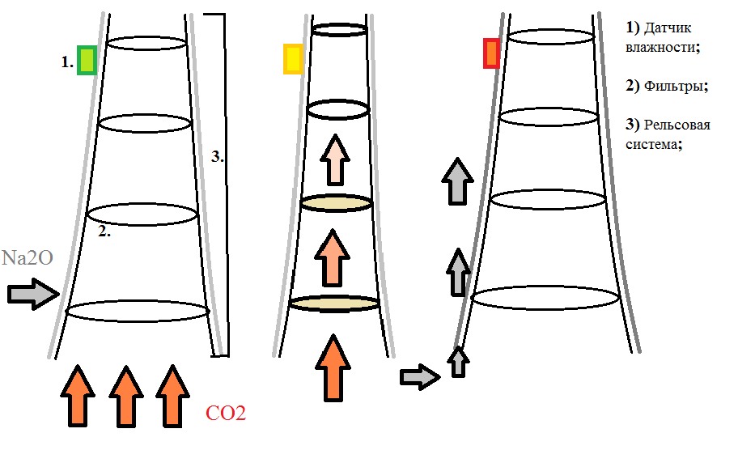 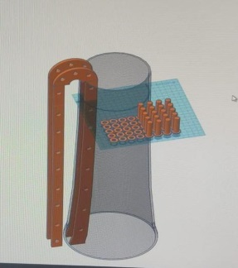

After the body was ready, we fastened the two parts of the rail system together and placed the rails in it, which half consisted of a caterpillar track, the other half was made of solid transparent oilcloth. The main function of this rail system is to move the filters through the pipe (up and down) with the help of motors that were attached to the bottom of the system, their movement is controlled by the program in EV3. For the engines, I made a lego structure that firmly attached them to the structures. Humidity sensors attached to the filters provide data to the program. In order to connect the sensors to the EV3, we have integrated two systems. The Arduino works with the EV3 by transmitting data via I2c. We connected three humidity sensors to I2c by soldering their wires to it.

**Advantages of the layout of the automated industrial gas extractor:**

• Thanks to the rail system and special sensors, the unit is completely autonomous and easy to repair;

• Efficient carbon dioxide absorber;

• Possibility of further processing of waste filters;

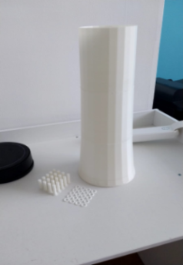 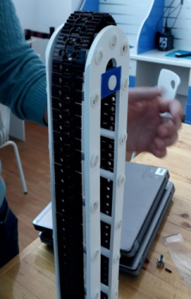 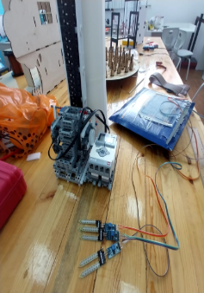 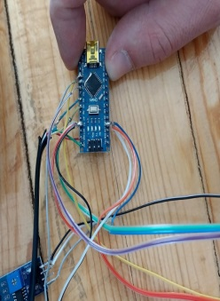 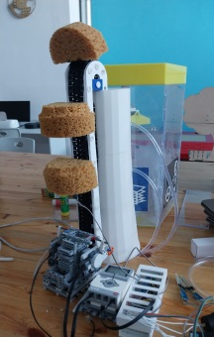**Conclusion.**

An automated, working installation was created, effective CO2 absorbers were investigated and applied. Eco-friendly ways of processing used filters were found.